ISSACK WAITHAKA
cs-sa07-24085

Red Team Recon

Introduction

- Reconnaissance(recon) is the investigation or surveying your target without alerting them
- it can be classified as passive or active

Taxonomy of Reconnaissance
- Passive don’t require interacting with the target while active requires interactions with the target directly
- Open source Intelligence is used to collect information about a target and can be viewed as a target publicly available social media profile
- External Recon is conducted outside a targets network focusing on the external assets available
- Internal Recon conducted from within the target company’s network

Built in tools
- Whois – Is used to find information of any domain name or website. Listens on Tcp port 43 for any incoming requests
- Nslookup – is used dns server to get the A and AAA records related to our domain
- Dig (domain information groper) – provides a lot of query options and also allows us to specify different dns server to use.
- Traceroute – Traces routes taken by our packets from our system to target host
-

Questions
1.
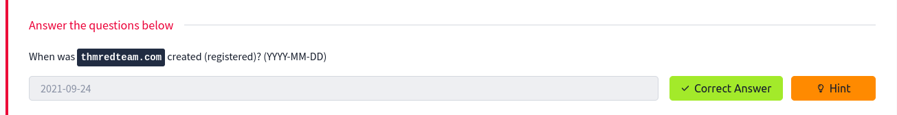

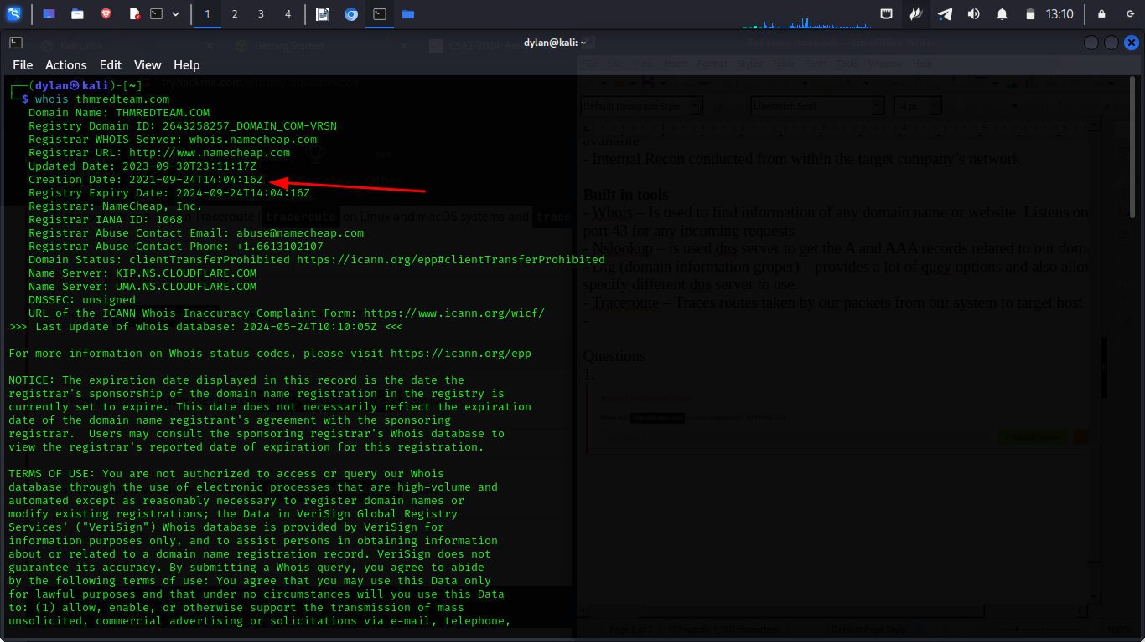
2.
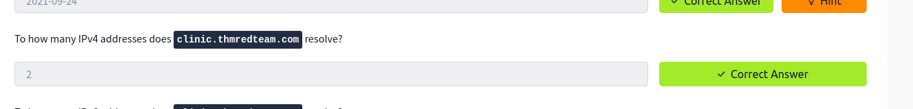
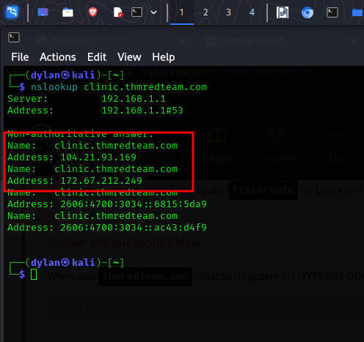

3.

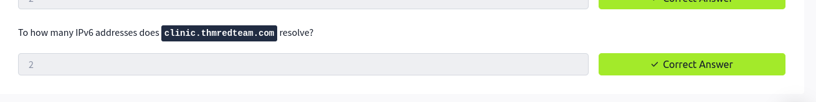
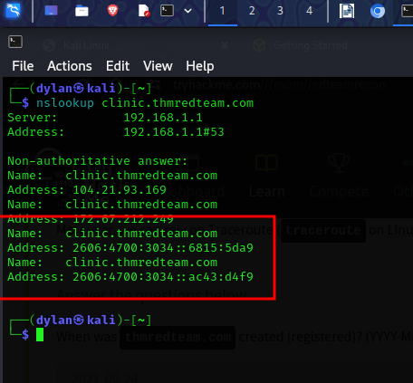

Advanced Searching
- We can make use of google advanced searches to search for specific terms
- Social media can reveal tons of information about the target

Questions
1.
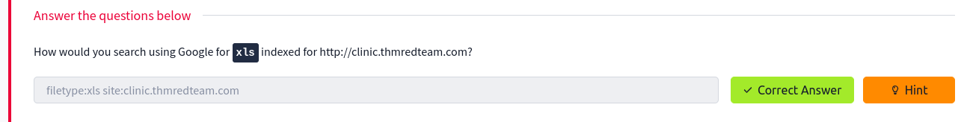

2.
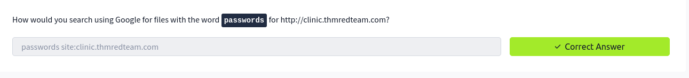

Specialized search engines
- Who is history provides a history of whois data
- ViewDNS.info – offers Reverse IP Lookup. This can be used to find servers sharing same IP addresses
- Threat Intelligence Platform – requires yo to provide a domain name of an IP. And launch a series of test
- Censys – Provide a lot of information about IP addresses and domains
- Shodan – Scans IP addresses for connected devices and identify open ports, unsecured devices and running services

Questions
1.
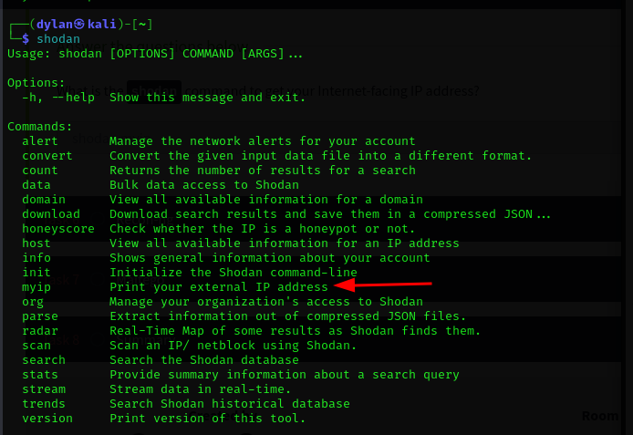

Recon-ng
- It is a framework that helps automate the Osint work
- It is started b the recon-ng command

Questions
1.

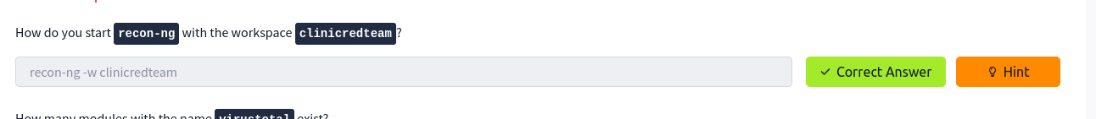
2.
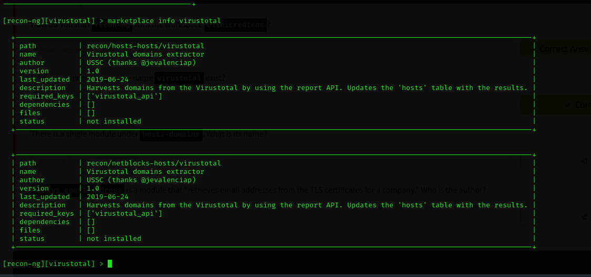

3.
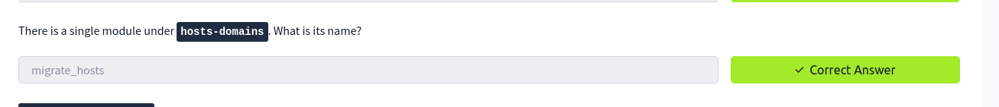
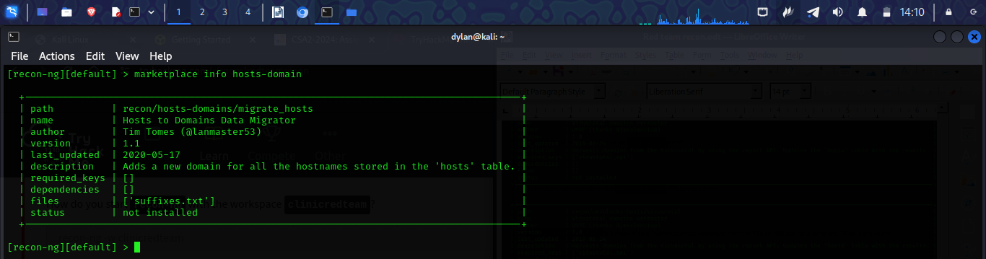
4.
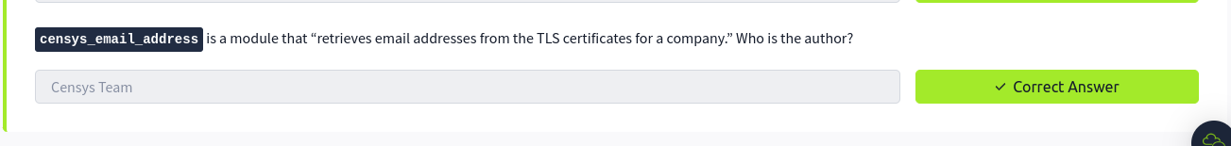

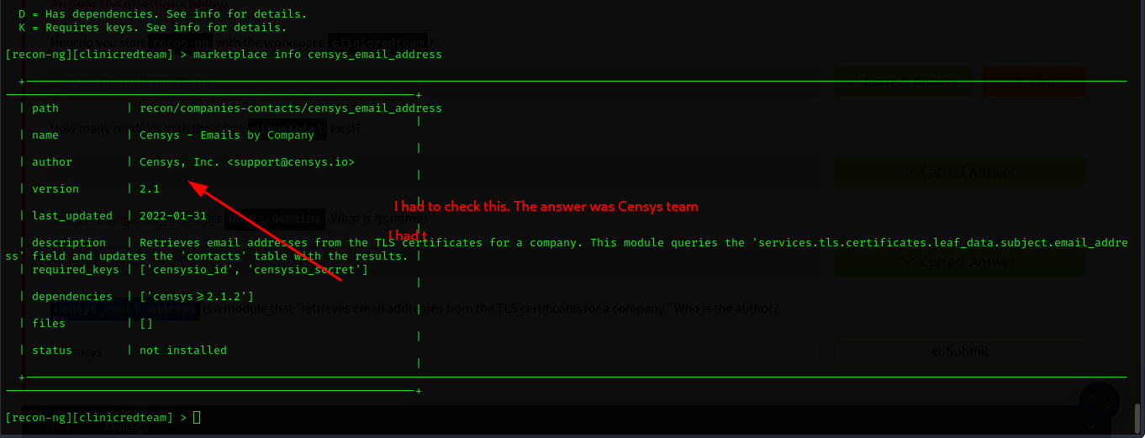

Maltego
- It allows us to quickly pull data from profiles, posts, and comments into one graph

Questions
1.
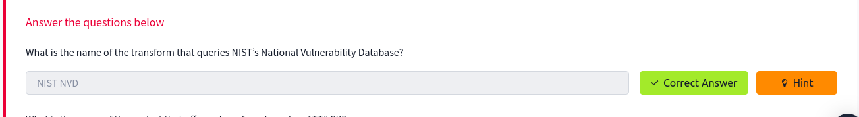

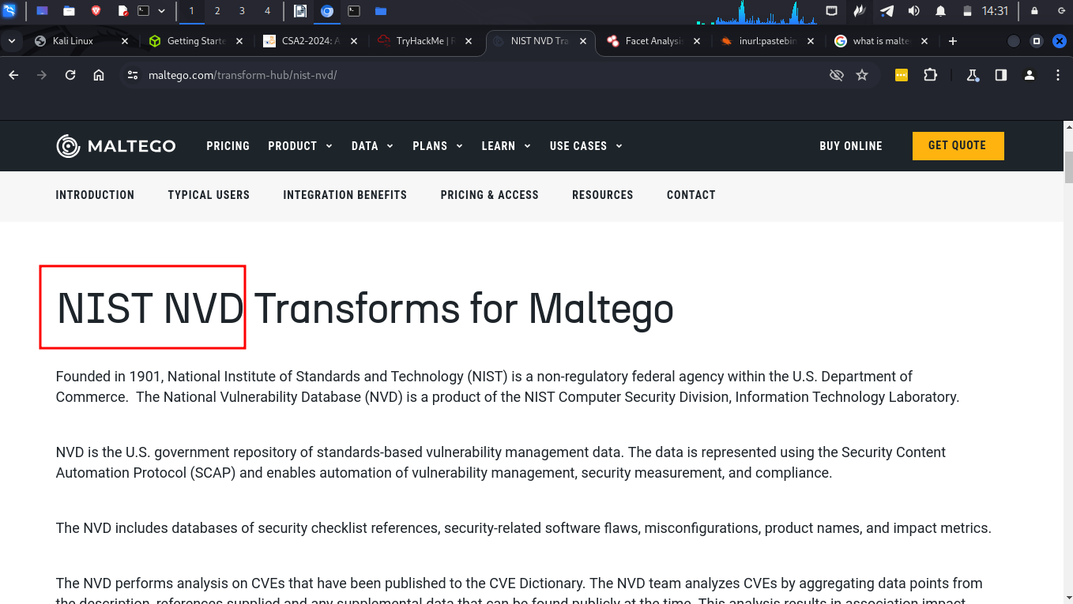

2.
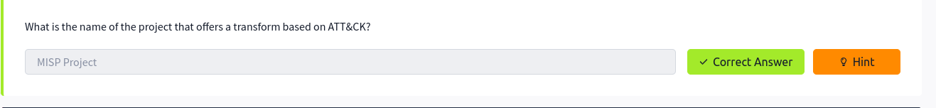
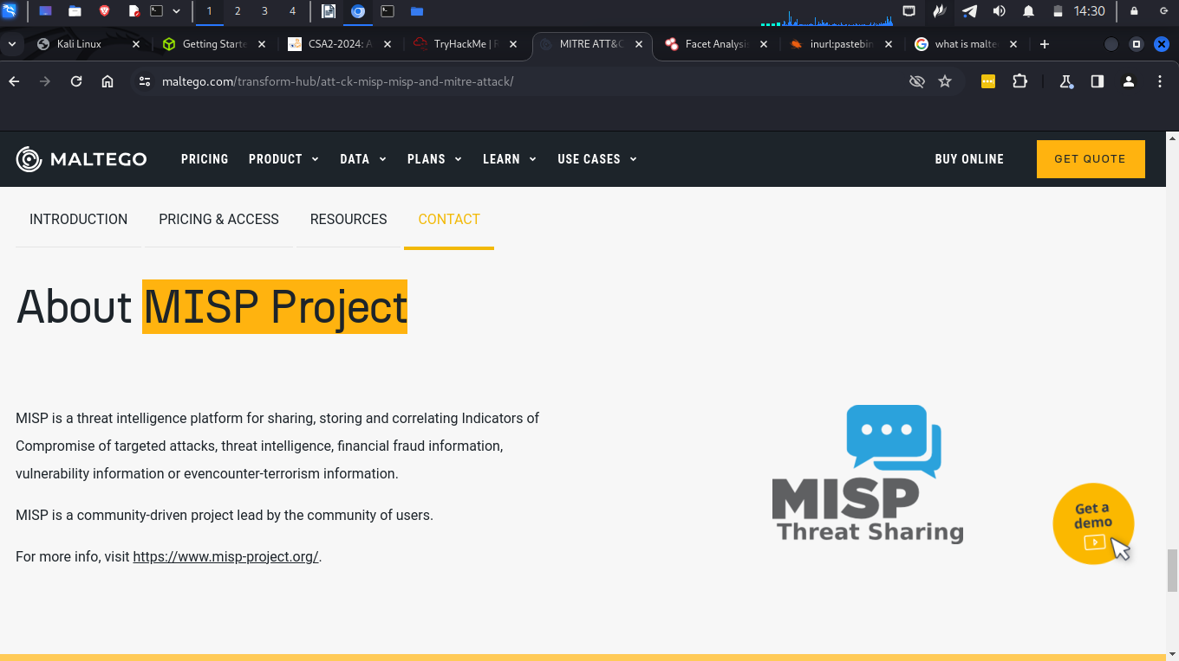

Conclusion
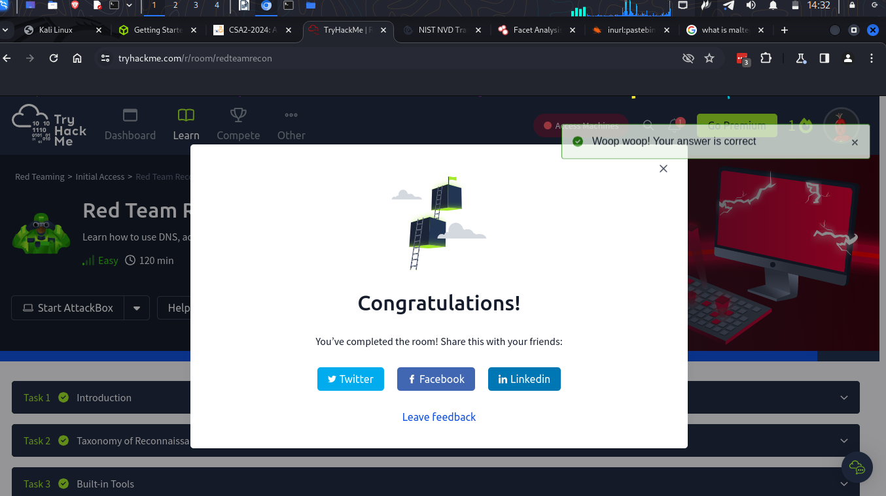

-In this module I learnt that we need to gain as much information as we can about a target. I went through some tools that may help me gather information about my target

